**Final Project**

1. Write a program to draw a quiz score histogram.

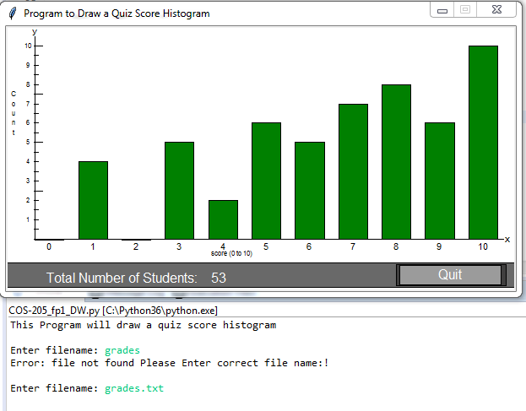

Error Handling Check

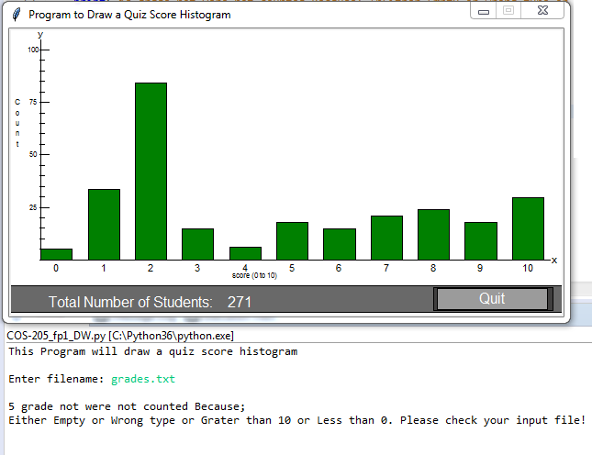

1. **Program that computes the sum of the squares of numbers read from the file**

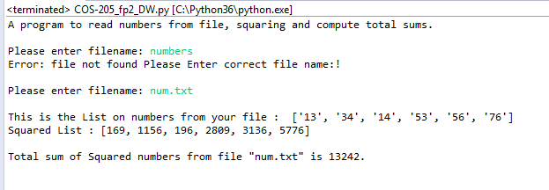

Error Handling Check

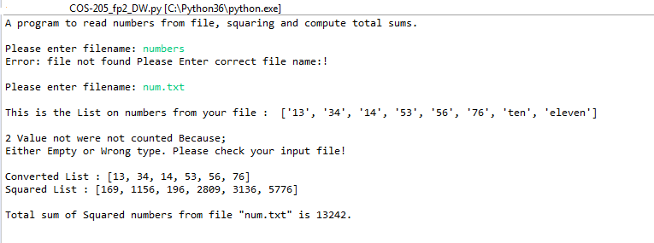

1. **Program that computes the sequential day of the year**

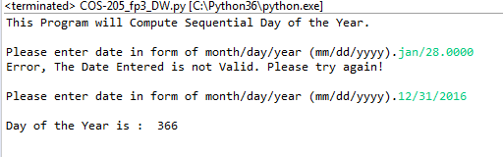

Error Handling Check

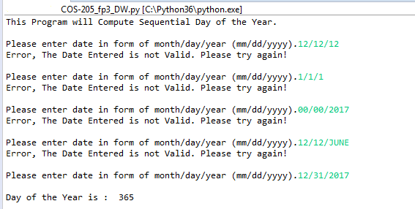

1. **Program that computes the fuel efficiency of a multi-leg journey**

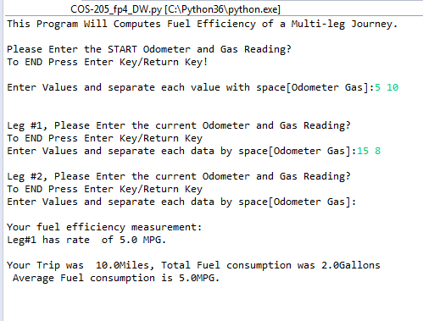

Error Handling Check

